CRIMES AND PUNISHMENTS

|  |  |
| --- | --- |
| Crimes | Punishments |
| Most Serious crimes (such as refusing to accept the authority of the Emperor or being a Christian) | Execution by crucifixion or being thrown to the lions. Being forced to become a gladiator. |
| More Serious crimes (murder, arson, libel and slander) | Execution (by various methods) Exile (only for the upper classes) |
| Major Crimes – (e.g. mugging) | Amputation of limbs |
| Minor Crimes – (e.g. petty theft or selling underweight bread) | Flogging (being whipped). Beating  Financial penalties (being forced to repay the cost of goods stolen or damaged) |

LAW ENFORCEMENT

|  |  |
| --- | --- |
| Title | Task |
| http://4.bp.blogspot.com/_cHJbFUIrg0g/TAnTpJicLLI/AAAAAAAADfE/Lexv5g-YKyI/s1600/praetorian.jpg | The Praetorian guard were the Emperor’s household guards. They were used only in emergencies to protect the Emperor from riots. This would only be applicable to Roman Britain if the Emperor was in Britain, apart from that it had no effect upon the lives of the Romano-British. |
| http://images.mocpages.com/user_images/10387/1211075567_SPLASH.jpg | The Urban cohorts ) about 3000 soldiers) operated in urban areas (towns) by stopping riots, but they did not have patrol the streets at other times! |
| http://monkeybizness.files.wordpress.com/2008/04/jesus-and-the-money-lenders.jpg | The Vigiles (about 7000 men) were used to patrol the streets at night. They were not properly trained like our police officers today but were expected to prevent fires and put out any that they found. They were also supposed to stop crime and chase runaway slaves! |
| http://26.media.tumblr.com/tumblr_kuaux5Pgym1qzotf3o1_500.png | The Aediles were only supposed to make sure that householders kept the streets outside their homes clean, that waste was not dumped into the rivers in towns and that shopkeepers did not cheat their customers by selling underweight bread. |

COURT SYSTEMS





**Courts and Trials**

There were three basic principles at work in Roman trials.

1. Any Roman citizen could bring a case to court.

2. The defendant was innocent until proven guilty

3. The defendant had the right to present evidence.

ATTITUDE TO CRIMINALS

Some criminals should get lighter punishments than others.

Deter criminals and rebels with harsh punishments.



Victims must have justice, even if it is vengeance in some cases.

Make an example of people who break the laws with public punishments.

A Police-force is too expensive – Criminals must be pursued by their victims.

|  |  |
| --- | --- |
| Crimes | Punishments |
| Most serious crimes (treason against the King) | Execution by beheading, burning or hanging. |
| More serious crimes (murder, arson) | Execution (most commonly hanging, but occasionally beheading, burning, stoning or drowning), payment of Wergild for murder and payment of Botgild for physical harm |
| Slander | Cutting off tongue |
| Stealing | Cutting off hands or feet |
| Major Crimes or repeat offences | Fines Confiscation of property  Beatings, floggings |
| Minor Crimes (e.g. petty theft) | Fines |

CRIMES AND PUNISHMENTS

LAW ENFORCEMENT

**The Tithing** was a group of **10 men** who had to be responsible for each others’ behaviour. If one of them committed a crime the others were responsible for getting him to court to face judgement otherwise they had to pay the compensation to the victim themselves.

All males **over the age of 12** had to belong to a Tithing. The men in each Tithing had to act as a system of collective responsibility by making each other follow the laws.

In each Tithing, one man had the role and responsibility of a leader, he was called the ‘**Tithingman’**.

**10 groups of Tithings** made a group called a **‘Hundred’**. They were led by a freeman called the ‘**Hundredman’**. The Tithingmen and the Hundredman were to meet every four weeks in the presence of a clerk. The Hundreds of men were then organised into **Shires\*** who were led by a **Shire-Reeve (Sherrif).**

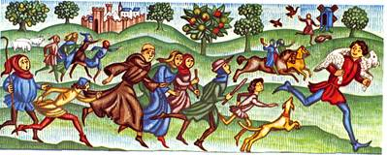

**Anyone witnessing a crime had to raise the ‘Hue and Cry’ for everyone to come running and chase a criminal or help to sort out a crime or fight. Not raising the ‘Hue and Cry’ or not responding to it was seen as a great crime.**

COURT SYSTEMS

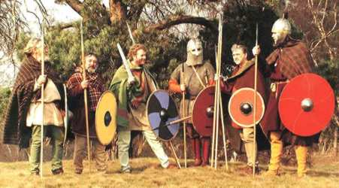Trial by the Community

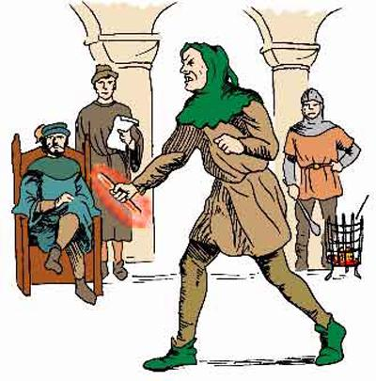 Trial by Ordeal

Types of Courts

|  |  |
| --- | --- |
| Royal Courts | The King decides cases involving his Lords or other serious crimes. |
| Shire Courts | Twice yearly in every Shire (region) to deal with serious cases such as murder. |
| Hundred Courts | Monthly for less serious cases. All freemen attended. |
| Private Courts | Within landowner’s Manor, for rule breaking, lazy workers or runaway slaves. |

ATTITUDE TO CRIMINALS

Criminals from the Church should use different courts and receive different punishments.

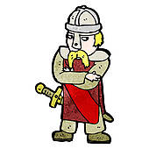

Make an example of people who repeatedly break the laws.

Use the community to make people follow the laws.

If we can’t tell if someone is really a criminal we will let God decide.

Deter criminals and rebels with harsh punishments but try to save their souls first.

We need more courts to deal with the different types of criminals.

A Police-force is too expensive – Criminals must be pursued by their victims and the community.

CRIMES AND PUNISHMENTS

|  |  |
| --- | --- |
| Crimes | Punishments |
| Most Serious crimes (rebellion against the King or the Norman leaders, heresy) | Execution by beheading, burning or hanging. |
| Serious crimes (murder, arson or repeat offenses) | Execution (most commonly hanging, but occasionally beheading, burning, stoning or drowning) |
| Major Crimes – (e.g. breaking the Forest Laws, mugging) | Beatings and floggingsAmputation of hands, arms, blinding in one eye etc |
| Minor Crimes – (e.g. petty theft) |  Fines, but paid to the Kings’ officials not to the victim’s family. Stocks or pillory |

LAW ENFORCEMENT

The Normans maintained the:

**Tithings and the Hue and Cry**

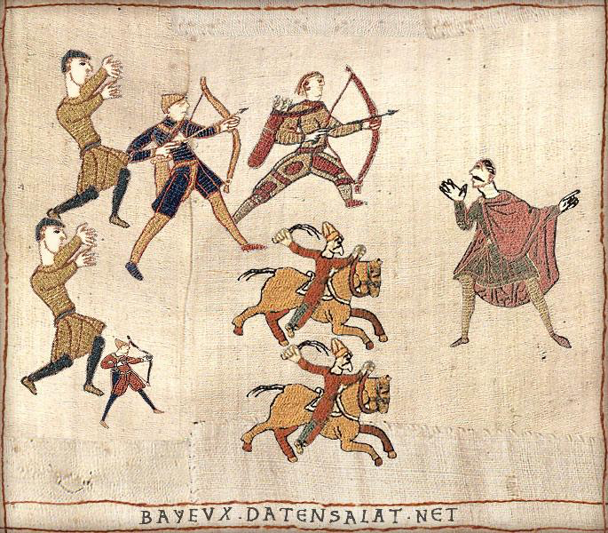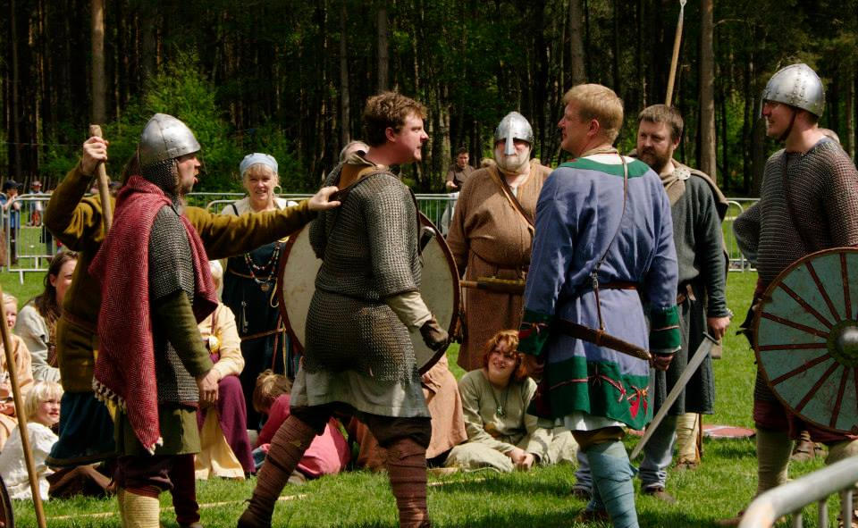

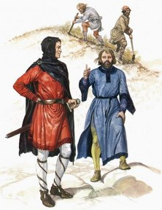

**They also increased the use and power of**

**The Shire Reeve (Sheriff) to keep the peace and uphold the laws.**

|  |  |
| --- | --- |
| Royal Courts | The King still decided cases involving his Lords or other serious crimes. Greater importance was placed upon crimes that broke the King’s Peace. |
| Church Courts | For Ecclesiastical crimes and crimes committed by members of the Clergy. |
| County Courts | These were essentially the old Shire Courts under a new name. They met twice yearly in every County (region) to deal with serious cases such as murder. William increased the power of the Shire Reeves (Sheriffs) to enforce the law. |
| Hundred Courts | Monthly for less serious cases. All freemen attended. |
| Private Courts | Within Norman landowner’s Manor, for rule breaking, lazy workers or runaway slaves. |

COURT SYSTEMS

At his coronation, William I promised to uphold existing laws and customs.

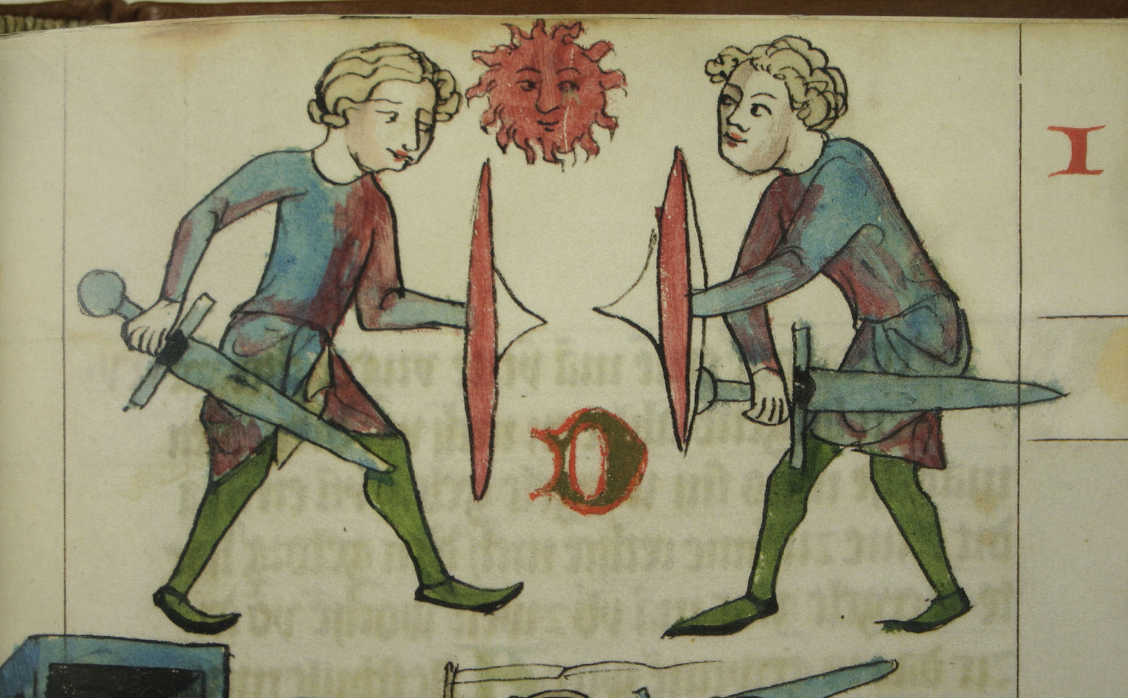Types of Courts

**Trial by Combat** was added to the methods used for when a Jury could not decide upon guilt or innocence.

ATTITUDE TO CRIMINALS

Criminals from the Church should use different courts and receive different punishments. Normans should be treated differently to Saxons.

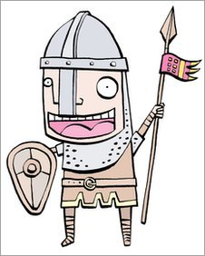

If we can’t tell if someone is really a criminal we will still let God decide.

Deter criminals and rebels with harsh punishments.

Intimidate the Saxons so that they will not try to attack us Normans!

We will keep the same courts for criminals but will increase the power of the King in law-making.

Keep using the community to enforce laws but put Norman nobles in charge not Saxons. .

Make an example of people who repeatedly break the laws.

CRIMES AND PUNISHMENTS

|  |  |
| --- | --- |
| Crimes | Punishments |
| Most Serious crimes (rebellion against the King or heresy) | Execution by beheading, burning or hanging. |
| Serious crimes (murder, arson or repeat offenses) | Execution (most commonly hanging, but occasionally beheading, burning, stoning or drowning) |
| Major Crimes – (e.g. breaking Forest laws and mugging) | Beatings and floggingsAmputation of hands, arms etc |
| Minor Crimes – (e.g. petty theft) |  Fines Stocks or pillory |

**Crimes in Royal Courts were divided according to their seriousness.**

**Trespass (usually punished by fines of money)**

* **Selling goods for the wrong prices**
* **Paying too high a wage to attract workers away from other villages**
* **Breaking legal agreements**
* **Assault**

**Felonies (crimes punished by hanging)**

* **Murder**
* **Rape**
* **Treason**
* **Arson**
* **Robbery (taking the property of another by force or fear)**
* **Theft of goods worth more than 12 pence (about 2 days’ wages)**

LAW ENFORCEMENT

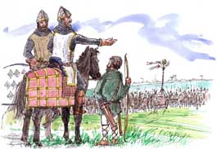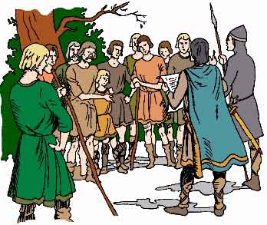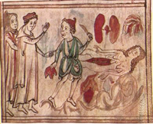

**Royal Writs -** A Royal writ is a written instruction from the King. These existed in Anglo-Saxon England but were not always used regularly. From the time of Henry II, Royal writs were used with more and more frequency to inform the powerful sheriffs of the King’s decisions about law and authority.

The Hue and Cry still existed but was led by the Constable after 1250. In 1285, Edward I passed a new law declaring that all men had a duty to help to form a *posse comitatus* (force of the county) to help the Sheriff to chase and catch criminals.

**County gaols –** In1154 counties now had their own prisons where accused people were kept before the Judge arrived to try their case.

After 1190, unusual local deaths were investigated by the Coroner.

COURT SYSTEMS

**Use of Juries**

In 1166, the Assize (Law) of Clarendon made it law to use ‘grand juries’ to investigate recent crimes. These had been used before but King Henry II decided to make them a more regular and important part of the legal system. They were not used to decide if someone was guilty or innocent though. In 1176, the Assize of Northampton gave the grand juries the power to decide if a case should be examined in further in court

Trial by Ordeal was used until 1215 to decide if someone was guilty or innocent, but he encouraged the use of new ‘petty’ juries to decide on a person’s guilt or innocence. In the reign of Richard I (1189-1199), a new legal official – the coroner – was introduced to help to investigate suspicious deaths and therefore help the juries. After Henry II the Petty Juries gradually became more important until by the end of the 14th century Trial by Jury was the normal method of deciding guilt and Trial by Ordeal was not needed.

**Travelling Justices in Eyre**

Under Henry II, England was divided into six ‘eyres’ or circuits and royal judges travelled around to hear the legal cases using the English Common Law.

In 1361, the Justices of the Peace Act was passed. JPs were local landowners who were allowed to hear less serious crimes – they held ‘Quarter Sessions’ 4 times per year. They eventually took over the work of the hundred courts and the Sheriffs courts.

**Church Justice**

Henry also attempted to reduce the legal rights and privileges of the Church, but by 1154 the Church was so powerful in the English legal system that Henry ***had*** to allow the Church courts to continue to exist. For example, the Church provided educated men to record laws, draw up the King’s writs and act as Judges. It also influenced the laws that were made and how the guilty were punished, so Henry had to accept the Church’s power if he wanted to use them to help him rule.

However, through the Constitutions of Clarendon in 1164 he did try to restrict its power. For example, he moved some property cases from the Church courts to the King’s courts. However, the Kings still needed them to arrest, torture and execute heretics. For example in the early 15th century, John Wyclif and his followers the Lollards were persecuted and executed for challenging the beliefs of the Church.

**Royal Writs -** A Royal writ is a written instruction from the King. These existed in Anglo-Saxon England but were not always used regularly. From the time of Henry II, Royal writs were used with more and more frequency to inform the powerful sheriffs of the King’s decisions about law and authority.

**The Court of Kings bench -** The most serious criminal cases were dealt with by a new court that was named ‘the court of King’s bench’. This existed from the 12th century onwards and it took some cases out of the local courts if they were thought to be serious enough.

ATTITUDE TO CRIMINALS

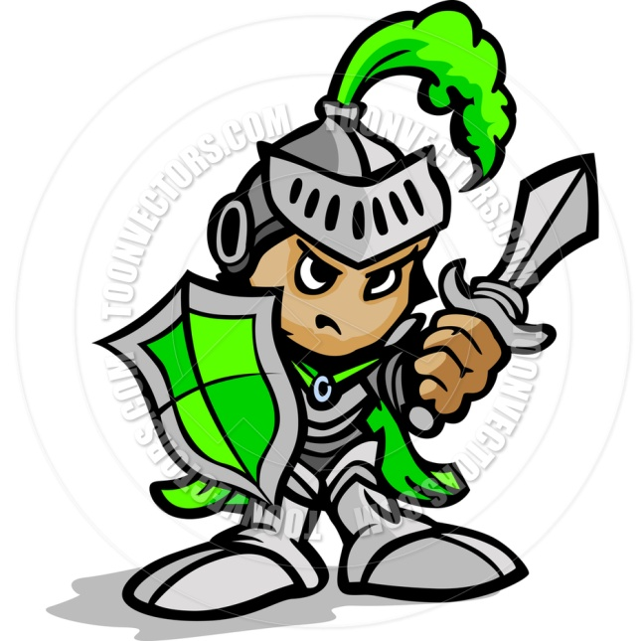

We still have no Police, BUT …The Constable, the Posse Comitatus and Sheriff will help to catch criminals and the Coroner will help to solve suspicious deaths so watch out lawbreakers!

Deter all criminals with harsh and public punishments. But nobles still get better treatment.

Criminals from the Church receive different courts and receive different punishments, but the King wants this to stop.

It’s time to replace Trial by Ordeal with Trial by Jury.

Using County gaols to hold prisoners will stop them committing more crimes until they can be heard by the Justices of the Eyres or the Jps. This will be faster and more efficient!

The Court of Kings Bench will deal with serious crimes more efficiently.

Using Royal Writs should make sure than everyone knows what laws to follow.

CRIMES AND PUNISHMENTS

|  |  |
| --- | --- |
| Crimes | Punishments |
| Most Serious crimes (Treason , Rebellion, Sedition, heresy) | Execution by beheading, burning or hanging. |
| Serious crimes (murder, arson, Witchcraft or repeat offenses of vagrancy or begging without a licence) | Execution (most commonly hanging, but occasionally beheading, burning, stoning or drowning) |
| Major Crimes – (e.g. Vagrancy, begging without a licence, repeatedly breaking laws and mugging) | Beatings and floggingsAmputation of hands, arms etc |
| Minor Crimes – (e.g. petty theft) |  Fines Stocks or pillory |

LAW ENFORCEMENT

**The Hue and Cry** and the **Posse Comitatus** were still used.

**The army** was used to put down protests or other riots or to capture gangs, particularly of violent smugglers. This was very unpopular because it seemed that the government was simply overpowering the people and ignoring their problems.

**Citizens** were still expected to deal with crimes themselves. If someone was robbed, it was their responsibility to get an arrest warrant from a magistrate, track down the criminal and if possible deliver them to the Constable. **Rewards** were offered for key criminals. For known Highwaymen the reward was £40 a sum equivalent to a year’s income for a middle class family.

**Thief-takers** made their living from tracking down criminals and collecting rewards. **They were often criminals themselves who set people up in order to gain money.**

**Watchmen** were employed to patrol larger towns by night and day. They had to arrest drunks and vagabonds and peer into windows to look for criminals. Sergeants were used to enforce market regulations and collect fines.

**Constables.** Two men from amongst the wealthier citizens were chosen to be Constables for one year. They dealt with everyday crimes such as vagrancy and gave out punishments such as whipping of Sturdy Beggars. They took charge of suspects and kept them in gaol until their trial.

COURT SYSTEMS

The King and increasingly Parliament set the laws.

Juries were still used and their roles increased as in 1600 juries would make decisions about lots of cases and once, but by 1700 juries dealt with one case at a time.

|  |  |
| --- | --- |
| Serious Cases | Royal Courts of Assize. |
| Quarter Sessions | Serious local crimes. |
| Church courts | Religious crimes and criminal clergymen. |
| Manor courts | For local crimes such as petty theft, selling underweight bread, drunkenness or poor moral. |

Final decisions about punishments were also made by.

Royal Judges – heard serious cases at the assizes.

Justices of the Peace (also called Magistrates) – at the Quarter Sessions.

Church Courts - Important Clergymen.

Manor Courts – Local Lords.

From the 1720s – Lawyers were also used in the MOST SERIOUS court cases.

ATTITUDE TO CRIMINALS

Deter all criminals with harsh and public punishments. Treason, Heresy and moral crimes must be stamped out! But nobles still get slightly better treatment.

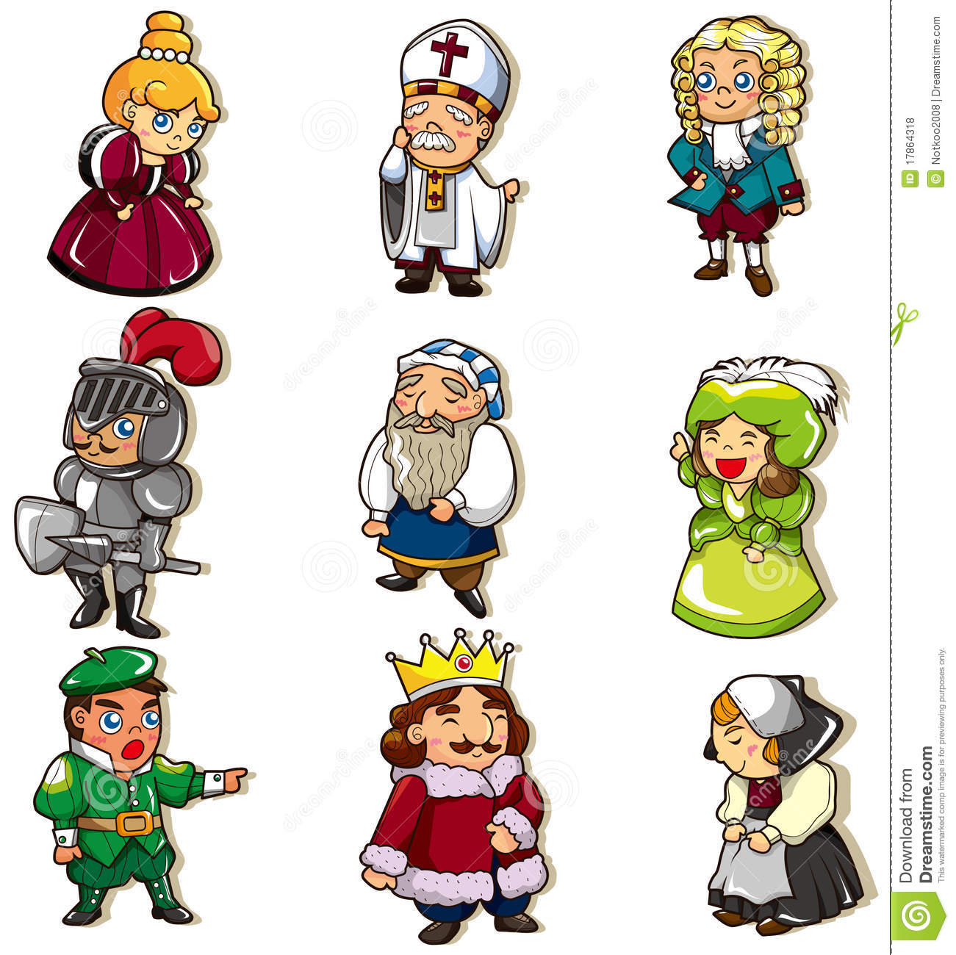

We still have no Police force, BUT we still have The Constable, the Posse Comitatus, the Sheriff, the Coroner, Thief takers and Watchmen. Oh, and if you rebel we will set the army on you!

We have widened the range of courts to deal with different types of criminal cases. The Monarch’s laws must be followed.

The King makes all of the laws about crimes although Parliament have a little influence here. From 1649 to 1660 all decisions were made by the Lord Protector and Parliament. After 1660 it was the King and Parliament again!

CRIMES AND PUNISHMENTS

|  |  |
| --- | --- |
| Crimes | Punishments |
| Most Serious crimes (Treason , Rebellion, Sedition) | Execution by beheading, burning or hanging. |
| Serious crimes (murder, arson, Piracy, smuggling, poaching and Highway robbery) | Execution (most commonly hanging, but occasionally beheading or burning) or later Transportation to the Colonies. |
| Major Crimes – (e.g. repeatedly breaking laws or mugging) | Execution (most commonly hanging, but occasionally beheading or burning) or later Transportation to the Colonies. |
| Minor Crimes – (e.g. petty theft, pickpocketing) |  Fines, whipping or later Transportation. Stocks or pillory |

LAW ENFORCEMENT

1. The public still had Constables, Watchmen, Thief-takers and the Hue and Cry.

8. 1829 The Metropolitan Police force was set up in London. It had 3200 men.

3. John and Henry Fielding set up a civilian horse patrol to stop highwaymen.

2. 1789 Thames River Police was established. Its objective was the prevention and detection of crime on the Thames and it became the forerunner of many other police forces in the world.

5. The Fieldings started a new publication called the *Hue and Cry* newspaper. It contained and passed on details of crimes and stolen property and was showed to magistrates and the public.

4. In 1805 the Fieldings introduced the Bow Street Runners. They were a team of paid thief-takers who patrolled the streets of London in the evenings.

6. In 1822 Sir Robert Peel was appointed Home Secretary. He supported the ideas of the Fieldings and increased the work of the Bow Street Runners to include a day patrol too.

7. According to the Duke of Wellington, by 1829 there were 18 different groups of people trying to prevent criminal behaviour in London, but none of them ever worked together!

9. 1829 The Metropolitan Police force was 1835 A new law said that town were allowed to set up their own police forces.

10. 1839 The Rural Constabulary Act said that counties were allowed to set up their own police forces. The Bow Street Runners and other forces in London were amalgamated (joined together) with the Metropolitan Police.

11. 1842 The Metropolitan Police set up the first detective force in London. By 1878 this was known as the CID (Criminal Investigation Department).

12. 1856 It became compulsory for all towns and counties to set up police forces.

14. 1870 Police helmets were introduced.

15. 1884 There were 39,000 police in Britain.

COURT SYSTEMS

|  |  |
| --- | --- |
| Serious Cases | Royal Courts of Assize. |
| Quarter Sessions | Serious local crimes. |
| Church courts | Religious crimes and criminal clergymen. |
| Manor courts | For local crimes such as petty theft, selling underweight bread, drunkenness or poor moral. |

There was little change from 1500 to 1750

The King and Parliament set the laws.

Juries were still used and their roles increased as in 1600 juries would make decisions about lots of cases and once, but by 1700 juries dealt with one case at a time.

Final decisions about punishments were also made by.

Royal Judges – heard serious cases at the assizes.

Justices of the Peace (also called Magistrates) – at the Quarter Sessions.

Church Courts - Important Clergymen.

Manor Courts – Local Lords.

Lawyers were also used in the MOST SERIOUS court cases.

ATTITUDE TO CRIMINALS

The Bloody Code led to a lot of executions, for minor crimes. Eventually we partly replaced this with Transportation or Prison; even if the prisons were overcrowded, cruel and full of pointless activities.

By the late 1800s we were finally moving towards having a Police Force!

Governments still thought that the worst crimes were protests against their power. They were afraid of revolution.



Urbanisation and increased taxation and transport led to the increase of crimes such as theft, smuggling, poaching and highway robbery.

By the late 1800s we were starting to recognise that upbringing, poverty and mental illness could cause people to commit crimes. The increase in scientific study meant that Witchcraft was not a crime! We began to think about rehabilitation and separate prisons for men and women.

CRIMES AND PUNISHMENTS

|  |  |
| --- | --- |
| Modern 20th Century Crimes | Punishments |
| Most Serious crimes (Terrorism) | Imprisonment |
| Serious crimes (murder, arson, smuggling, poaching, sexual crimes, forgery, drug crimes, large scale theft) | Imprisonment |
| Major Crimes – (e.g. repeatedly breaking laws or mugging) | Imprisonment |
| Minor Crimes or first time offenders | Anti-Social Behaviour orders, Fines, Community Service. Suspended Sentences |

LAW ENFORCEMENT

**New Techniques:**

**Fingerprints**

**CC TV, radios and headsets**

**Forensics, DNA Databases**

**Batons and Tasers**

**Police cars and motorbikes**

And we have WPCs now too!

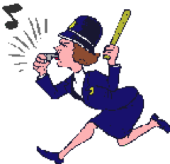

**Overview:** There are 60 police forces in the UK. This number includes specialist, non-geographic forces such as the Civil Nuclear Constabulary, British Transport Police and the Ministry of Defence Police. There are 43 geographic forces in England and Wales, one in Scotland (Police Scotland), and one in Northern Ireland (Police Service of Northern Ireland). There are currently 209,400 officers serving in the geographic England and Wales forces, over 17,000 in Scotland, and nearly 8,000 in Northern Ireland.

There are many different types of jobs in the police service. These include:

* Police officers
* Police community support officers (England and Wales only)
* Special Constables/Volunteers

• Police Staff

Some of our Specialist Police Units include:

The Fraud Squad - established 1946.

Drugs and Narcotics Squads.

The Metropolitan Patrol Group – Established 1965, renamed 1987, deals with inner-city riots, disturbances and threats to public order.

The Anti-Terrorist Squad 1971.

The UK Border Force – Renamed 2012 – deals with Immigration and Border Security.

Customs Officials

Coastguards

**The Community are still involved**

**With Neighbourhood Watch and**

**Crime-watch UK too!**

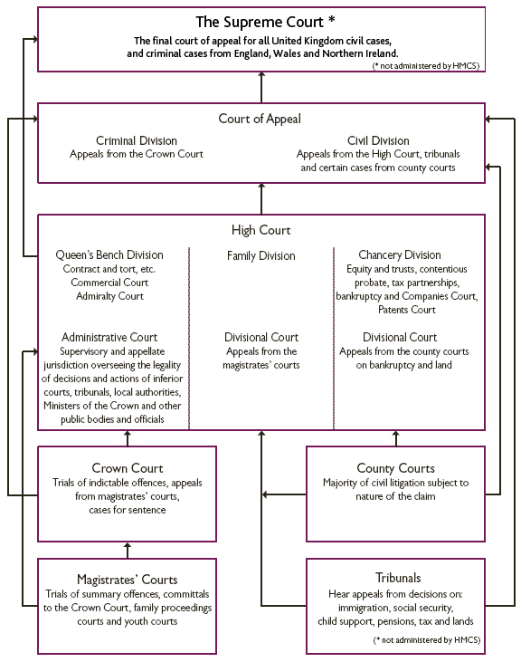 COURT SYSTEMS

European Court of Justice

European Court of Human Rights

ATTITUDE TO CRIMINALS

It is no longer a crime to choose your religion, your political allegiance, whether to be a soldier or even your sexuality. But you are not allowed to impose your ideas on ooothers.



Finally we women have a right to vote upon what to do about crime and criminals! Oh, and it is a crime to hurt us now too!

We treat men, women and children separately.

New technology has brought new types of crime but also new methods of detection

We recognise that upbringing, poverty and other circumstances such as mental illness and radicalisation can cause people to commit crimes.

We don’t execute criminals any more. We use prisons, fines probation and community service to rehabilitate criminals.

We have a wide range of courts to deal with criminals and victims fairly, efficiently and rapidly.