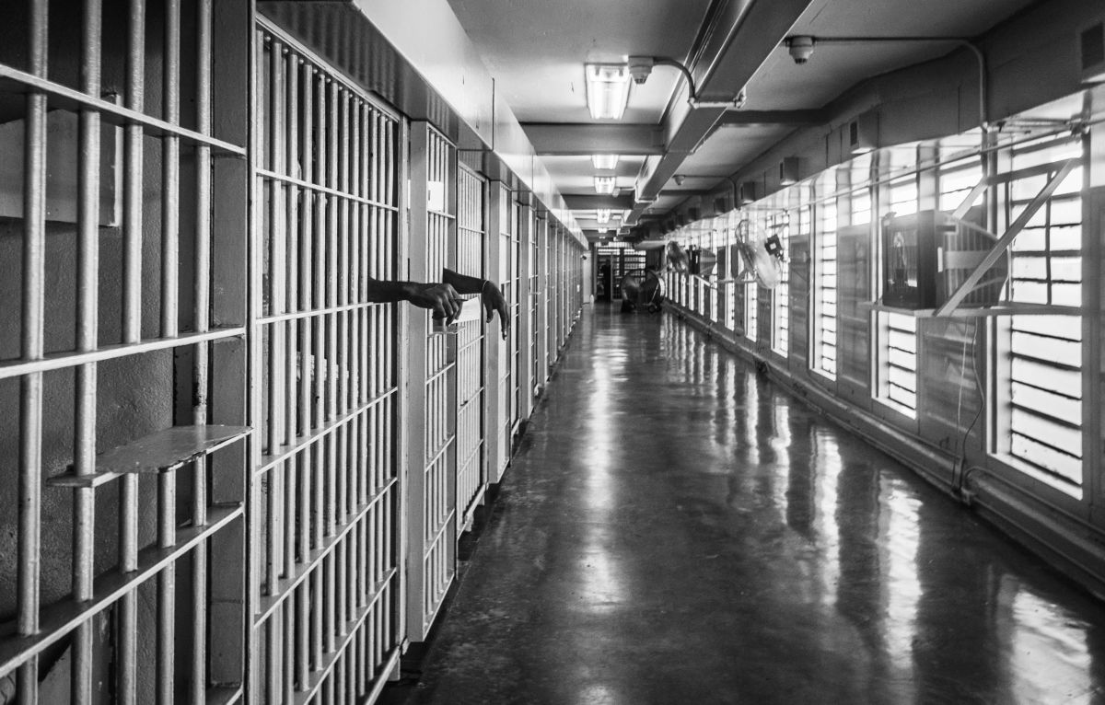
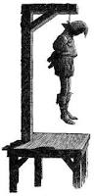
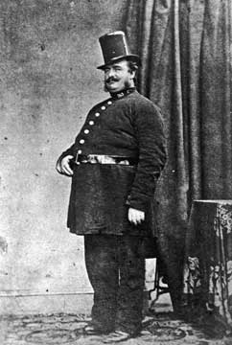
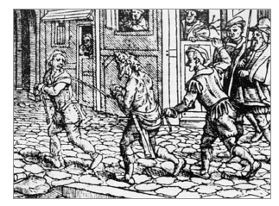
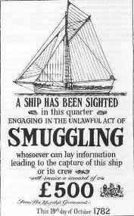
Revision Guide – Crime and Punishment
Acland Burghley School
History
A guide filled with capacious notes and activities to expand the mind and feed the brain…
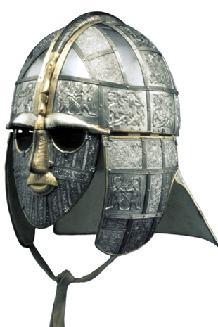
Saxon Crime:

Crime | Punishment
Minor crime, eg. Petty theft | - Fines
Major crimes or repeat offences | - Fines  - Confiscation of property  - Beating / Flogging
Stealing | - Cutting off hands or feet
Slander | - Cutting off the tongue
More serious crimes, eg. Murder, arson | - Execution, usually by hanging, but occasionally by beheading, burning, stoning, or drowning
Most serious crimes, eg. Treason | - Execution by beheading, burning, or drowning

Saxon Ideas on the law:
- There was less professionalism in the law under the Saxons. Until Alfred the Great, the law was based on the ideas of the local landlords. Each area could have ended up with its own laws as a result of this.
- Any crime against the King was considered treason, and persistent re-offenders would also be executed.
- The King tried to reduce violence by using the Wergild, a monetary penalty for crimes, rather than the Blood Feud – a revenge based system.
- Society was organised into hundreds (a group of 100 farms) and tithings (10 men). Each hundred or tithing was responsible for policing itself. If somebody committed a crime, the tithing or hundred was responsible for making sure they attended court or they faced a fine themselves.
- Anybody who did not attend court when they were supposed to was called an outlaw, meaning they lost all of their legal protection.
- The Church was given more emphasis as the basis of the later Saxon Kings’ power.
Law Enforcement under the Saxons:
- King Alfred the Great collected all of the laws in England from c.871.
- Tithings and Hundreds were responsible for policing themselves, or they faced fines.
- Once accused, individuals had to be presented at the courts by their Tithing (or the Tithing faced a fine), and the victim and defendant had to present evidence. Juries who knew both men would hear the case and pass a judgement.
- Trial by ordeal (boiling water, hot iron, or cold water) was only used in cases where the jury could not reach a decision.
- Trial by sacrament was a specific trial for priests, involving eating holy bread without choking.

Norman Crimes:
Crime | Punishment
Minor crimes – eg. Petty theft, slander | - Fines  - Pillory and stocks
Major crimes – eg. Mugging, Breaking Forest Laws | - Beatings and floggings.  - Amputations, largely of hands, or arms.
More serious crimes – Eg. Arson, murder, repeated breaking of Forest Laws | Execution (usually hanging, but sometimes beheading, burning, stoning, or drowning).
Most serious crimes – Eg. Rebellion and heresy | - Execution by beheading, burning, or hanging.

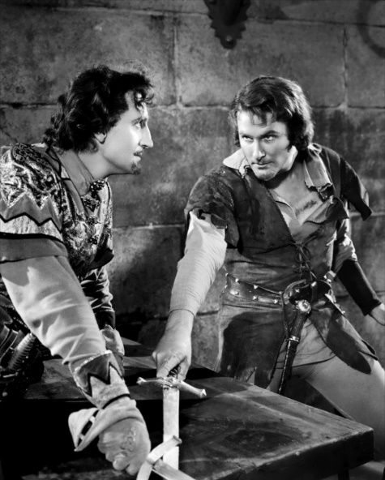
New Norman Ideas:
- The Mund – This was an area around the home that belonged to the home owner, that they had a right to defend.
- The country was therefore the King’s Mund, and he had a right to defend the King’s peace.
- 30% of the land in England was designated as Royal Forests, protected by the King’s laws, even if this land now covered villages or farms.
- Hunting or taking wood from the King’s Forests was now illegal, and carried harsh punishments.
- New wardens were in charge of enforcing this new law.
- Trial by Combat was introduced as well as Trial by Ordeal. God would grant the innocent party victory in single combat.

The Role of the Church:
- The Church was allowed to set up its own courts to deal with ‘moral crimes’, eg. Adultery, blasphemy, or sex before marriage. The Death Penalty was not available.
- Benefit of Clergy was to help priests avoid harsh punishments in court by reciting a specific passage from the Bible and being sent to a Church Court.
- Criminals could gain Sanctuary in a Church. If they admitted their guilt to a priest, they would be allowed to choose exile.
- Priests were the ones required to administer the trials by ordeal and by combat. This lasted until 1215 when the Church finally demanded that Trial by Ordeal be banned.

Later Medieval Crime and Punishment:

Crime | Punishment
Minor crime, eg. Petty theft | - Fines  - Amputation  - Stocks or Pillory  - Whipping
Major crimes or repeat offences | - Fines  - Confiscation of property  - Beating / Flogging
Stealing | - Cutting off hands or feet
Slander | - Cutting off the tongue
More serious crimes, eg. Murder, arson | - Execution, usually by hanging, but occasionally by beheading, burning, stoning, or drowning
Most serious crimes, eg. treason | - Execution by hanging, drawing, and quartering
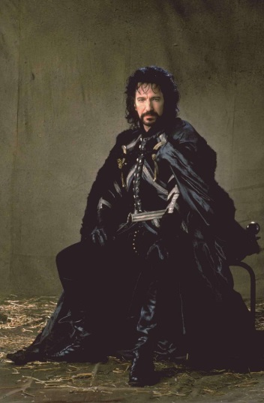
Later Medieval Changes:
- Henry II introduced the Constitutions of Clarendon, a standardised set of laws.
- Royal Judges used the new standardised laws.
- All counties were required to build gaols, or jails, to hold prisoners.
- The most serious cases had to be tried in London, not in local courts, at the King’s Bench.
- Church officials were required to act as judges.
- Local sheriffs were given power to catch criminals.
- Law enforcement sheriffs were made more powerful than local landowners.
- The position of Coroner was created to report on all suspicious deaths.
- Trial by jury became the normal method of deciding guilt by the end of the 1400s.
- In 1361, local landowners were made Justices of the Peace who had the power to hear less serious criminal cases at Quarter Sessions held four times a year.
- The Posse Comitatus was created.
- Fewer death sentences were handed out, as the Church encouraged leniency.
- Crimes were divided into felonies, which were punished by hanging (Arson, Treason, Robbery, Murder, theft of goods worth more than 12 pence, rape), and Trespasses, punished by fines (Selling goods at the wrong prices, paying high wages to attract workers away from the land, breaking legal agreements, Theft, Assault.

Avoiding Punishment:
- Become an approver buy successfully accusing 10 criminals.
- Join the Army in times of War.
- Buy a Pardon from the Crown.
- Claim Sanctuary.
- Take the Benefit of Clergy and hope it worked.
- Women could get pregnant.

Courts in the Middle Ages:
Royal Court | Manor Court | Church Court
- Tried the most serious crimes.  - Held only for serious crimes, not at any other point.  - Held in London, so criminals had to be sent there.  - Tried ‘Felonies’ – Murder, rape, arson, treason, Robbery, and theft of goods worth more than 12 pence.  - Punishment for any of these crimes was usually hanging.  - Trial was conducted in front of a jury with evidence presented.  - Some chance of ‘getting off’. | - Tried less serious crimes.  - Held in local communities by local landowners, who later became Justices of the Peace (JPs).  - Held quarterly sessions.  - Tried ‘Trespasses’ – Selling goods for the wrong prices, paying too high a wage to attract workers away from other villages, Breaking legal agreements, Assault, Theft.  - Punishment was a fine.  - Almost all who went before the manor courts were found guilty. | - Tried immoral crimes or priests accused of breaking the law.  - Held in local areas, often behind closed doors.  - Not held regularly.  - Punishments were often lenient, often leading to people trying to have their trial in a Church Court.  - Monarchy had no power over them.

Women could not attend any court, unless they were accusing somebody of murdering their husband, or of raping them, or attacking her leading to the death of an unborn child.
Exam Questions:
- Why did punishment change from the Saxon period to the Norman period? 12 marks.
- Why did law enforcement change from the Saxon period to the Norman period? 12 marks.

Task: Summarise the key issues in each of the two periods below.
Saxon Crime: | Norman Crime:

1450 – 1750, Renaissance Crime:
Crimes | Punishments | Crime Prevention
Begging and Vagrancy  Theft  Murder  Arson  Treason  Religious non-conformism  Witchcraft  Poaching, smuggling, highway robbery | Whipping and being sent back to your home village. Later laws stated that anybody caught begging twice could be executed.  Whipping or amputation.  Execution.  Execution.  Hanging, drawing, and quartering.  Usually punished by fines, though some preachers and repeat offenders were executed.  Burning  Usually execution. Towards the end of the period, transportation. | Hue and Cry: Locals would call for help and assistance from those nearby.  The constable: First appointed in 1250. Not regular police, just local volunteers who tried to keep the peace. Only had the job for a year.  The Watch: Local volunteers who kept the peace at night and handed over any wrongdoers to the constable.  The sheriff: Had to track down criminals and imprison them for trial. Could summon a posse to help prevent crime.  Courts: Church Courts dealt with priests. Manor courts dealt with normal villagers and dealt with minor crimes. Royal courts dealt with all serious crimes, such as murder, arson, rape, treason, and robbery, which were punished by execution. Assault, selling goods at wrong prices, etc, were punished by fining.

Key dates in Renaissance Crime and Punishment
1531 | Beggars must be classed as either deserving poor or sturdy poor.
1534 | Monasteries are closed.
1536  1547 | Pilgrimage of Grace rebellion.  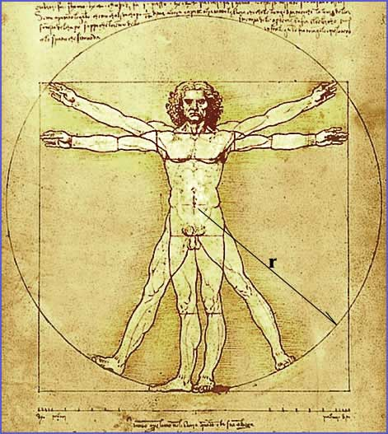  Vagrants should be whipped and branded.
1550 | 1547 Act abolished.
1572 | People caught begging twice can be executed.
1576 | Houses of Correction are to be built in all counties.
1601 | Poor Law established.
1605 | Guy Fawkes arrested and killed.

Changes in Courts:
- Trial by Jury became normal.
- Trained lawyers began to be more frequently used, for the prosecution first, and then the defence.
- Trials became more formal, and royal judges began to travel the country.
- Nobody could be arrested without trial (Habeas Corpus).
- Juries now dealt with only one case at a time, though each case took only 10-15 minutes.
- Manor courts were still used for small crimes, but Church Courts began to decline.
What informed attitudes:
- Growth in towns led to higher rates of theft and pick-pocketing, as there were more places for people to hide.
- Improved quality of the roads made it easier for highwaymen to attack travellers.
- New ideas on farming meant that a lot of people lost their jobs, leading to more unemployed people.
- New ideas on religion took away the support of the Monasteries that the poor had always received. This led to more unemployed people.
- The King was believed to be appointed by God. Anybody that broke the King’s law was challenging the authority of God.
- There was no regular police force, and no way of providing one, as the government did not receive too much money. People resented taxes.

Activity:
What were the ‘typical’ criminals of the Renaissance? Draw a diagram below for each type of ‘typical’ criminal and label it.
Beggar: | Witch:

Begging and Vagrancy
Why was it a crime? | How was it dealt with? | Changes?
- Closure of the monasteries took away support for the poor.  - Population increase put pressure on jobs and food.  - Landowners wanted to keep sheep instead of growing crops, which needed fewer workers, therefore there were more unemployed.  - The cost of supporting beggars was resented.  - Poor people were more likely to turn to other crimes, like theft, as well as begging.  - People felt threatened by travelling beggars. | - 1531: A law passed by Parliament separated the deserving poor from the sturdy beggars. Beggars were to be classed as either deserving a licence or punished. Deserving Poor: Sick or injured beggars who were worthy of help. Sturdy Beggars: Healthy people considered to be too lazy to work. | - 1547 Vagrancy Act: Forced beggars to work. It also ordered that they should be whipped and branded. This law, though, was impossible to enforce.  - 1550: The 1547 act was abolished.  - 1572: First offence led to whipping and the burning off of an ear. Second offence was execution.  - 1576: Houses of Correction should be built in every county to punish and employ persistent beggars.  - 1593: The 1572 Act was abolished.  - 1598: Vagrants were to be whipped and sent home. If they did not change their ways, JPS could send them to prison, banish them, or execute them.
Realities:
- Most villages tried to support genuine poor.
- Many ordinary citizens lived ‘in terror of the tramp’.
- Most beggars were not criminals.
- Most beggars were the genuine poor and unemployed looking for work.
- In normal years, vagrancy and begging was not a problem.
- London had the biggest problem. Many people believed London offered employment opportunities, while others believed that it offered good opportunities for crime.
- Even in 1560, London only had 69 vagabonds.
- The number of vagrants increased after bad harvests. In the 1570s, the number of vagrants had grown to 209 per year.

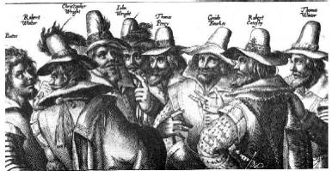

Treason:
Treason was not a common crime. The Tudors were particularly worried about it because they had seized power by force and there were people who questioned their right to rule. These tensions increased after the break from the Catholic Church.
In 1536, the Pilgrimage of Grace broke out against Henry VIII and over 30,000 people rebelled. While the government made a deal with the rebels, the leaders were arrested and subjected to hanging, drawing, and quartering. The bodies of over 700 rebels were displayed around the country to deter other rebellions.
Later rebellions against the Tudors were all dealt with harshly, with leaders often executed by hanging, drawing and quartering.
Hanging, Drawing, and Quartering had been the punishment for traitors since the later middle ages (1300s) as people believed that the body needed to be complete ready for judgement day when they believed people would stand before God and either be allowed into Heaven, or go to Hell. It was believed that if peoples’ bodies were cut into parts, then people would not be able to get into Heaven and would be condemned to Hell for eternity.
In 1605, Guy Fawkes was accused of Treason.
- The conspirators planned to blow up the King and his Parliament at the state opening of Parliament in November 1605.
- The plan was to then start a rebellion and put a Catholic on the throne.
- There were several leading conspirators, mostly from leading Catholic families.
- Guy Fawkes was an explosives expert.
- The conspirators were betrayed and the leaders were sentenced to be hanged, drawn, and quartered.

Each plot against the Tudor or Stuart monarchs was difficult for the authorities to deal with, as they had very little way of finding out that plots were taking place, especially when communications were limited to face-to-face communication, or private letters.

Exam question:
- Explain how the treatment of terrorists (rebels) changed from the 16th and 17th Centuries to the modern period c.1900 – present. 4 marks
- Explain the difference in difficulties faced by the authorities in dealing with terrorism between the 16th and 17th Centuries and the modern period c.1900 – present. 4 marks

Witchcraft:
Why was it a crime? | How was it punished? | Changes?
- Crimes against the Church were seen as crimes against the state as a result of the Reformation.  - Many in power believed in witches.  - After the closure of the monasteries, there was less help for old women, and people resented charity.  - Some women did not fit a stereotype and were seen as odd.  - In such an unsettled time, people were looking for a group of people to blame.  - Religious non-conformism (heresy) was treated harshly.  - Unemployment and prices rose, wages dropped. There were more unemployed people. | - Witches could be found guilty on weak evidence, such as the confession of two other ‘witches’, owning a pet animal, or the confessions of children.  - Witches were punished harshly. In the 17th Century they were often hanged or burned.  - Matthew Hopkins accused 36 women in Manningtree, and 19 were executed.  - Women could be tortured for their confessions. | - Hopkins was stopped in 1647, partly because he used torture, which was illegal.  - The economic situation calmed down. People were not so jealous of neighbours, and resented charity less.  - The Royal Society in 1660 began to disprove many superstitions and beliefs. People became more rational.  - The last execution was in 1684.

Date | Event
1542 | Henry VIII passes a new law where witchcraft becomes a crime against authority.
1563 | Increase of prosecutions under Elizabeth I after a new law that defines major and minor witchcraft.
1604 | Major witch-hunts after James I enforced all other witchcraft laws.
1642-49 | The English Civil War led to the worst period of witch-hunting.
1685 | The last execution for witchcraft.
1736 | All witchcraft laws were abolished.

Factors that led to witchcraft no longer being treated as a crime:
- Economic and social changes – Greater prosperity and political stability reduced social tensions. More help was given to the poor after 1601, and the social problems created by the Civil War ended in 1660. England was much more settled by 1707.
- Less superstition: People did still believe in God and the Devil, but they stopped believing in them as physical forces in their lives. This is largely due to more education.
- Science: The foundation of the Royal Society in 1660 meant that more scientific experimentation could take place. This led to people being less superstitious, and things that were previously blamed on witchcraft could be explained.
Matthew Hopkins:
Called himself the Witch Finder General and accused 36 women in Manningtree in Essex, 19 of whom ended up being executed for witchcraft. His methods were aggressive and violent, using torture (which was illegal at the time) to force women to confess to their ‘crimes’.
He would use the ‘confessions’ of other witches, witches marks (moles, extra fingers or nipples, birth marks, etc.), evidence of ‘possessed’ children, and even the strange behaviour of household animals as evidence against the accused.
Those executed for witchcraft were hanged, not burned (that was only the punishment in parts of Europe). While we know for certain that Hopkins is responsible for the deaths of 19 women, he may have been responsible for the deaths of up to 200 women during the period 1644 – 1647. He is believed to have died of an illness in 1647, though some have suggested he himself was accused of witchcraft.

The End of Witchcraft:
Witchcraft laws were abolished in 1736, although unofficial witchcraft trials carried on into the late 18th Century.
Knowledge check: Explain why witchcraft eventually declined.

Jonathan Wild:
Who was he? | Importance? | Relation to questions?
- A famous criminal from 17th Century Britain.  - Named himself the Thief-Taker General, and arrested ‘thieves’ he claimed his agents had tracked down.  - He would return the stolen goods for a reward.  - ‘Criminals’ were often members of his gang that refused to do as they were told, or rival gangs.  - Responsible for the deaths of over 60 thieves.  - Was a fraud, as he organised the robberies and ran criminal gangs.  - Eventually arrested and hanged in 1725. | - Proved how little law enforcement there was.  - Proved that executions were an area for crimes as well as for public sympathy for criminals.  - Was occasionally presented as a heroic figure and a folk hero, highlighting the difficulties facing law enforcement. | - Questions on Jonathan Wild (usually 9 marks).  - Questions on the police in 18th Century Britain (or lack of it).  - Questions on the problems surrounding public executions.
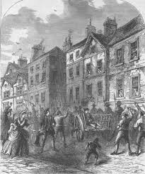
Exam Question:
How different was the system of law enforcement in the 17th and 18th century compared to law enforcement in the Middle Ages?
4 marks.
The Bloody Code:

Year | Number of crimes punishable with the death penalty
1688 | 50
1765 | 160
1815 | 225
Why?
- The Bloody Code was introduced as a way of scaring people into being law-abiding.
- The Bloody Code was designed to use such severe punishments that people would be too scared to break the law for fear of being punished.
- Those in authority were scared by the growing numbers of poor people.
- Rising unemployment made many scared that the poor would turn to crime instead of fall into poverty.
Realities:
- The Bloody Code made several things punishable by death that seemed to be relatively minor crimes. These included stealing sheep, damaging trees, and stealing rabbits.
- Commoners were hanged, drawn, and quartered for serious offences like treason, or hanged for others.
- Nobles were beheaded.
- Women were burnt at the stake for killing their husbands.
- Juries would often refuse to convict somebody of a minor crime that would lead to the death penalty.
- Fewer people were hanged in the 18th Century than in the previous century.

Changes:
- Transportation was increasingly used, sending prisoners to America until 1776 (American Independence), or Australia.
- In 1823, Sir Robert Peel reduced the number of crimes punishable by death by over 100, as so few people were being executed.

Exam Question:
Explain why the Bloody Code was used in Early Modern Britain. 12 marks
Explain why it was difficult to enforce the law during the period c1450–c1800. 12 marks

Renaissance Crime and Punishment Summary diagram:
Summarise what you have learnt.

Smuggling:
Why was it a crime? | How was it dealt with? | Changes?
- Import duties on luxury items and imported goods made people angry.  - Import taxes were unpopular.  - It was difficult to enforce import taxes, as England had several thousand miles of coast, and very few agents to police them.  - For many people, smuggling was a quick way to make money.  - A smuggler could earn 6 or 7 times a labourers pay.  - Anyone who helped carry goods could expect twice a farm labourer’s pay.  - Many industries were in decline, which led to people turning to crime. | - Under the Bloody Code, smuggling was a capital offence. | None.
Realities:
- Smugglers worked in large gangs to get their products organised quickly.
- They would arrive early in the morning, sell merchandise for 4 hours, and then leave.
- Duffers and hawkers would help to sell smugglers’ merchandise.
- Three million pounds worth of tea was smuggled into Britain each year.
- There were not enough revenue officers to deal with the problems of smuggling.
- If smuggled cargo was ever confiscated, smugglers often got it back through force.
- 70% of smugglers were labourers.
- Less than 10% were small farmers.
- Some wealthy people smuggled, including Robert Walpole who went on to be Prime Minister.

Exam question:
Explain why smuggling laws were so difficult to enforce in the 17th Century. 12 marks

Poaching:
Why was it a crime? | How was it dealt with? | Changes?
- Only landowners, whose land was worth over £100 a year weer allowed to hunt.  - Landowners with land worth less than £100 a year could not hunt.  - Hunting on somebody else’s land was considered to be poaching, which was illegal.  - Poaching was seen to be a crime against authority.  - Poaching laws protected the land of the very rich.  - Poachers were dangerous, as they often disguised themselves and were armed, also signs of rebellion. | - In 1723 the Black Act made hunting deer, hare or rabbits a capital crime punishable by death. Anyone found armed, disguised or with blackened faces in any hunting area was assumed to be poaching and could also be executed.  - Possessing dogs or snares that could be used for hunting was punished by a £5 fine or three months in prison. Critics of these laws believed they were simply there to protect the interests of rich landowners. | - The 1723 Black Act made poaching punishable by death.
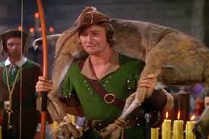
Realities:
- Many people who poached had done so since before the landowners acquired their land in the 1600s.
- Poachers often resorted to violence when they were caught.
- Communities often refused to work with game-keepers or constables trying to arrest poachers.
- Some people, seeking the rewards of handing over poachers, named poachers.
- For many, poaching became a trade. They would sell to inn-keepers, and to stage-waggoners, who would buy and sell for people in cities.

Exam Question:
Explain why poachers in the 18th Century were punished so harshly. 6 marks.

Highway Robbery:
Highway Robbery was usually armed thieves (often working in groups) stopping carriages on the roads and demanding money or jewellery from the occupants.
Why was it a crime? | How was it dealt with? | Changes?
- It was theft.  - It was often violent.  - The victims were usually wealthy landowners (or their families).  - Instances of highway robbery often ended in violence – one woman had her tongue cut out to prevent her talking.  - Often took place at the edge of towns and built up areas, where it was less likely robbers would be caught – the wealthy were already concerned about these areas. | - Highway Robbery was a capital crime.  - In the mid-1700s, the Bow Street Runners were established in London to help deal with highway robbery.  - The Bow Street Horse Patrol was also established to deal with highway robbery. | - Bow Street Runners established.  - More omnibus / stage coach services made it harder for highway robbers to steal from coaches.  - Growth of towns and cities led to robbers struggling to find areas to operate in that were not overlooked.

Misconception | Reality
Highwaymen were glamorous, daring, masked, and well dressed. | Most could, provided they were in open countryside. The few who ventured into towns found it harder to escape as there were more people in the way, but still managed to avoid the law.
Highwaymen were polite to their victims, especially women, and never used violence. | Highwaymen were seen as a major danger by traders and travellers, as they were so violent, and they often disrupted trading routes between towns.
Victims were happy to hand over their purse and even carried two purses, just in case of robbery. | Highwaymen were cruel and violent. One robber’s mask slipped during a robbery and his female victim recognised him. He cut out her tongue to stop her reporting him.
Highwaymen were able to escape quickly on horseback. | Highwaymen were often unemployed or ex-soldiers. They were not the popular myth figure of a ‘gentleman of the road’.

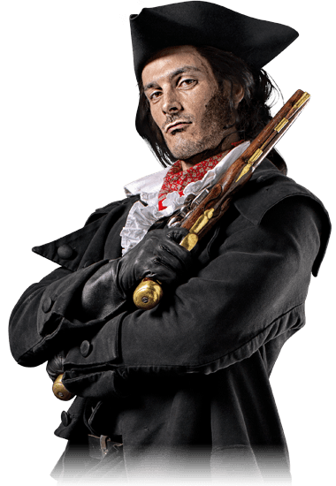
Famous Example: Dick Turpin.
Dick Turpin was born in Essex in 1705 and spent a brief period of time working as both a smuggler and a housebreaker in order to earn a living. He eventually became a highwayman, joining forces with another highwayman (Tom King) after trying to hold him up. They operated around the outskirts of London, and frequently visited the Spaniards Inn in Hampstead to sell what they had stolen, or hide from the authorities. They were so successful that the government eventually offered a reward of £100 for their capture.
Turpin was ruthless. He preyed on women travelling alone, as they were most likely to give him money without a fuss, and he is known to have killed at least one man who tried to arrest him. In May of 1737, Turpin and King were cornered by the authorities and King was killed. It is believed the before escaping, Turpin shot him so he couldn’t talk. This was a common reaction amongst highwaymen to those who could identify them (one highwayman had cut out a woman’s tongue to stop her identifying him).
Turpin eventually escaped to Yorkshire where he set up as an anonymous horse thief, and was arrested over shooting a cockerel. He wrote to his brother to ask him for help getting out of prison, but his brother refused to accept the letter. Turpin’s former school teacher saw the letter at the post office and identified Dick Turpin’s handwriting, telling the authorities they had arrested a notorious highwayman. Turpin was executed in 1739.

Exam Question:
- Explain why Highway Robbery increased over time. 12 marks
- Explain why social crimes increased in the 18th Century. 12 marks
Ending of the bloody code:
Key dates in the abolition of the Bloody Code
1789 | Last Woman burned for murdering her husband
1806 | Sir Samuel Romilly entered Parliament
1808 | Romilly gets a law passed abolishing death for pickpocketing.
1820 | Last beheading – of the Cato Street conspirators who tried to assassinate the entire government.
1820-1830s | Abolition of nearly all capital crimes
1841 | Only murder and treason remained as capital crimes
1868 | Last public hanging took place

Reasons
Public executions were not working:
- Severe punishments were meant to frighten people into keeping the law but they did not work. While executions happed crowds laughed and drank and more crimes were committed.
- The London magistrates admitted in 1783 that ‘all the aims of pubic justice are defeated’. That it wasn’t achieving what it was supposed to, people were not afraid of death and did not see punishment as shameful.
- There were huge crowds at public executions, the government felt that there was always danger of escape if the criminals were popular, or the crowd thought them innocent.
- There was an increasing risk of protest riots if there were mass hangings when offenders were sentenced to death for minor crimes.
Juries would not convict:
- When the courts were finding offenders not guilty simply because they thought sentencing them to death was too harsh, then the code was actually stopping the law from working. It was not protecting the property of the wealth and middle class.
- In the early 1700s only 40 % of those convicted of capital crimes were hanged. By 1800 crime had increased but the number of convictions went down to 10%. Juries did not wasn’t to convict people of minor capital crimes because they thought the punishment unfair.
- If courts were unwilling to convict criminals, criminals would feel even more confident of escaping punishment and might be more likely to commit more crimes.
Ideas about punishments were changing:
- Politicians had already started to look for and use alternatives to capital punishment such as Transportation. Transportation was the main alternative. The majority transported had originally been sentenced to death and then had their sentence reduced.
- The ‘enlightened’ view of punishment was that it should be proportional; that it should match the crime and not be unduly brutal. Criminals should be reformed by the correct punishment in to thoughtful human beings.

Exam question:
Describe two key features of the bloody code. 4 marks
Explain why the Bloody Code was ended. 12 marks

The Impact of Industrialisation
Industrialisation meant the arrival of machine and steam power for manufacturing, agriculture and transport.
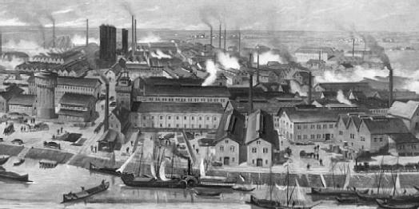
Impact on work and society:
- Huge factories in towns and cities, rather than people working at home in their villages.
- Workers replaced by machines in some industries and agriculture.
- Urbanisation as people moved into towns and cities to find work. The poor settled in poor areas where huge slums developed.
- Industrialisation made some people very rich but meant extreme poverty for others.
- Government brought in new laws or used existing ones to raise money and control people.
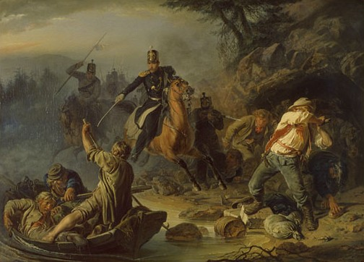
Impact on Crime:
There was an increase in crimes such as:
- Street theft and burglary
- Drunk and disorderly behavior
- Prostitution (including child prostitution)
- Rioting, public disorder and protests
- Smuggling of illegal goods.
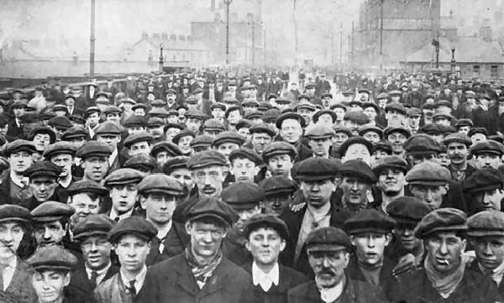
These crimes increased because:
- Travel and movement into towns meant it was harder to keep track of people.
- Large towns made it easier to escape being caught within dens or gangs of thieves
- Extreme poverty created ‘survival’ crimes such as stealing food.
- The poor worked alongside the rich; the poor felt discontented, which the rich sometimes felt threatened by the poor.

Exam question:
Describe two key features of industrialisation. 4 marks
Explain why crime increased as a result of industrialisation. 12 marks

New Crimes in the Industrial Revolution:
Crimes against Authority:
- The number of charges for treason fell, but government fears of Revolution, like the French Revolution, made them very tough on protestors.
Examples of Crimes Against Authority:
Threat | How it was dealt with?
Groups who wanted the right to vote and reform of Parliament, meeting in St Peter’s Fields, Manchester. | Soldiers were sent in to arrest the leaders, but ended up attacking protestors. It became known as the Peterloo Massacre. New laws were passed banning unauthorised meetings, and increased punishments for criticising the government.
A group of farm workers who formed a trade union to stop wage cuts in Tolpuddle, Dorset, 1833. | The farm workers were arrested for swearing a secret oath and transported to Australia. The government was forced to release the Tolpuddle Martyrs seven years later after huge protests, marches, and a petition.

Crimes against the Person:
- Violent crimes decreased, although many people actually believed they were on the rise, thanks to media portrayals.
- The 1850s ‘garrotting craze’, where robbers used chloroform or half-strangled their victims to make it easier to rob them, is an example of this.
- In 1888, the sensationalist stories in the newspapers about the ‘Jack the Ripper’ case made many believe that society was becoming more violent.

Exam Question:
Explain why attitudes towards crime and punishment changed between 1750 and 1900. 12 marks
Point 1 | Point 2 | Point 3

Policing and Law Enforcement:
Policing before the 1800s:
- Hue and Cry: Locals would call for help and assistance from those nearby.
- The constable: First appointed in 1250. Not regular police, just local volunteers who tried to keep the peace. Only had the job for a year.
- The Watch: Local volunteers who kept the peace at night and handed over any wrongdoers to the constable.
- The sheriff: Had to track down criminals and imprison them for trial. Could summon a posse to help prevent crime.
- Courts: Church Courts dealt with priests. Manor courts dealt with normal villagers and dealt with minor crimes. Royal courts dealt with all serious crimes, such as murder, arson, rape, treason, and robbery, which were punished by execution. Assault, selling goods at wrong prices, etc, were punished by fining.
- The Bloody Code: 225 laws that carried the death penalty by 1815. Designed to deter criminals from committing crime.
Key dates in the history of policing:
Date | What happened?
1749 | The Bow Street Runners were set up, a group of individuals who would track down criminals and stolen property, NOT prevent crimes.
1754 | The Bow Street Horse Patrols were set up to help patrol the streets, though there were not enough patrols to actually cut crime.
1829 | Robert Peel introduces the Metropolitan Police Act, which set up the Police Force in London.
1842 | The Detectives Department was set up which began to try and solve crimes.
1856 | It became compulsory for all counties and boroughs to have a police force.
Crumbs, it’s the Rozzers!
- Peel was keen for the police to have a new uniform that did not look like a military uniform to build trust (the army had been unpopular when they policed the streets).
- The police focused on patrolling areas where crime was high, which often helped to reduce street crimes and public disorder.
- Recruits were carefully selected and well trained.
- The police were not particularly popular at first, but people came to trust them.
- The crime rate fell dramatically after the foundation of the police.
- Within a few years of starting up, roughly 80% of original recruits had been sacked because they used violence and ‘the baton’ too often to solve problems. This proved the police monitored themselves well.
Exam Question:
Explain why the role of the police has changed since the mid-nineteenth century. 12 marks
Explain why attitudes towards a regular police force became more positive between 1700 and 1900. 12 marks.
Punishments, 1750 – 1900:
Date | What happened?
1615 | Transportation to America begins.
1770 | Eastern Australia claimed for Britain.
1774 | Gaol Act. Suggested how health and sanitation in prisons could be improved.
1776 | American War of Independence stops people being transported to the US.
1787 | Transportation to Australia begins.
1787 – 1868 | Over 160,000 people transported to Australia.
1823 | Gaols Act created paid gaolers, work, basic education, prison inspections, visits from chaplains and doctors, women gaolers for women prisoners.
1830s | Prisoners were given clean, separate cells and more work, starting a new Prison Building programme and the Separate system.
1842 – 77 | 90 new prisons built.
1850s | Transportation slows down.
1868 | Transportation is abolished.
1869 | Public execution was banned.
Why Transportation? And why did it end?
- Transportation was seen as a humane way to punish people without the death penalty.
- Transportation was a humane alternative to the death penalty.
- Transportation provided free labour for building in newly discovered colonies, like Australia and America.
Examples of Transportation offences:
- Stealing 4 pennies – 10 years.
- Stealing 2 coats – 7 years.
- Transportation removed criminals from British society.
It ended because:
- The American Civil War stopped transportation to America. The War with France made transportation to Australia more difficult and expensive.
- Eventually, Australia no longer needed slave labour. The discovery of gold in Australia meant that it was an attractive place to go and work, not a place for criminals.
- Some felt that transportation was too expensive, and not a good enough deterrent, as many transported people started a new life.
- Others felt that transportation was too harsh, especially on the criminal’s family.
- More prisons had been built, and they were cheaper than transportation.

Exam Question:
Explain why transportation was ended in 1868. 12 marks.
Why did the authorities start using transportation as a punishment in the 1660s and stop using it in 1868? 12 marks.

Ending public executions:
- Public execution was supposed to be a deterrent.
- Many public executions were a home to crimes, such as pickpocketing, or violence.
- Many claimed the atmosphere at executions was like a carnival.
- The crowd often showed sympathy to the criminal, and sometimes there were riots.
- The last public execution took place in 1869, though the procession of the condemned had ended by 1783.
Exam Questions: Explain why public executions were ended in 1869. 12 marks

P1 | P2
P3 | Good words to use:

New Prisons:
Separate System | Silent System
- Prisoners were kept in separate cells for most of the day.  - Prisoners were allowed out of their cells for exercise, lessons, or religious instructions.  - Whenever out of their cells, prisoners were hooded, or escorted to separate cubicles for lessons and religious services.  - Prisoners often did work in their cells.  - Very expensive. | - Prisoners were forced o work in silence, though they could be in the same room.  - Punishment was usually hard labour, or some form of useful work.  - Prisoners were encouraged to reflect on their actions and repent.  - Very expensive, and dangerous if prisoners rebelled.
Why prisons?
- Restitution – Work in prisons to pay back society.
- Retribution – To punish people for wrong-doing.
- Deterrence – To discourage others from committing crimes.
- Removal – Keeping criminals away from society.
- Rehabilitation – To change the person for the better.
Who changed Prisons:
John Howard – His work led to the 1774 Gaols Act which encouraged health and sanitation in prisons, though it was not compulsory.
Elizabeth Fry – Her work, visiting women in Newgate Prison in 1813, added pressure to the government to reform prisons for women. Fry set up education classes to reform female prisoners, and got them better food, clothes, and treatment.
Robert Peel – Home Secretary in 1823, he created the Gaol’s Act, 1823. This provided pay for gaolers (to end bribery and corruption), work for prisoners, separate prisons for men and women and children, inspections, women gaolers for women prisoners, visits by chaplains and doctors, and a basic education.
How successful?
- Howard and Fry wanted reform, but the government wanted retribution.
- Many prisoners committed suicide as a result of the new, harsh, separate and silent systems.

Exam question:
Explain why there were changes in the prison system during the nineteenth and twentieth centuries. 12 marks

Design a prison:
In the spaces below, draw and label the ‘ideal’ of each type of prison.
Separate prisons:

Silent prisons:

Crime since 1900:
Changes in society:
In the 20th Century, Britain became:
- Multi-cultural
- More prosperous
- More equal
- Technologically advanced
Each of these changes led to a growth in ‘new’ and old crimes. For example:
- Multi-cultural – Greater awareness of racial discrimination and racism in general.
- More prosperous – More things to steal.
- More equal – Greater awareness of sexual and racial discrimination, as well as discrimination against the disabled.
- Technologically advanced – More things to steal, more ways to steal them, new crimes to commit in terms of traffic offences, increased opportunities for fraud, and new ways to commit old crimes.
Common crimes:
- Driving offences and car theft (TWOC-ing).
- Vandalism / Burglary.
- Assault / Mugging.
- Petty-Theft / Anti-Social behaviour.
Rising Crime Rates:
The crime rate in Britain rose steadily throughout the 20th Century (except for notable dips in the First and Second World Wars) and reached a peak in 1992. It has been declining since. This could be for several reasons:
- More actions became classed as a crime, and new crimes appeared, eg. Computer hacking, racial discrimination, illegal downloading, etc.
- Victims of crime became more likely to report it.
- Ways of recording crime improved.
- Some say this proves people have less respect for others, and for authority.
What changed?
- Conscientious objection (refusing to fight for moral reasons) became a new crime when conscription was introduced for World War I.
- Cowardice in the face of the enemy was a crime during World War I, even if it was people suffering from shell-shock. This has now changed and is treated, rather than punished.
- Traffic crimes, like speeding, dangerous driving, driving while on the phone, have all become crimes.
- Racial discrimination has been made a crime since the 1968 Race Relations Act.
- Domestic Violence became a crime in 1976.

New Crimes?:
New Crime | Old Crime
Smuggling illegal drugs and legal items, such as cigarettes and alcohol, without paying tax. | Smuggling illegal items and legal items without paying tax.
People trafficking – selling people for prostitution and hard labour. | White slavery was a 19th Century phenomenon.
Sealing money or gaining bank details from people through fraud using modern communications. | Stealing or conning money from someone using fraud has happened for hundreds of years.
Antisocial behaviour, like being drunk and disorderly, or causing a disturbance. | This has been happening for years.

Policing in the 20th Century:

New Technology and Policing:
- Finger Printing, 1901.
- Radios, 1910.
- Cars, motorbikes, and helicopters, later 20th Century.
- CCTV, 1970s.
- Computers, 1980.
- DNA Evidence, 1995.

Changes in Policing:
- Modern policing is about preventing crime, not just catching criminals.
- Motorised transport means that police can reach crimes faster. However, it also means fewer police officers on the streets, which some people dislike.
- Some police officers are now armed (SO19), which makes them more like soldiers.
- The modern police force includes women, and officers from other ethnic groups.
- In 1982 Neighbourhood Watch groups were set up across the UK. These groups help people prevent and detect crime. The police often work closely with these groups to advise and educate.
- In 2002 Police Community Support Officers were introduced.

Changes in Policing, 19th Century – 20th Century:
Task: Label the differences between a 19th Century Peeler and a modern police officer.

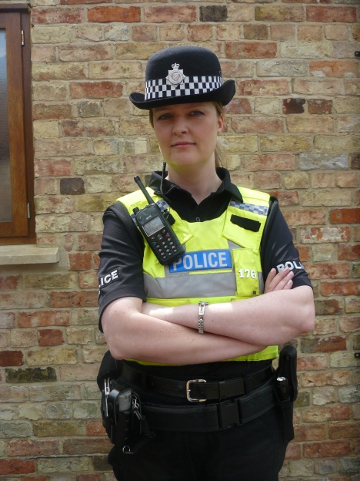

Abolishing Capital Punishment:
Capital Punishment was abolished in 1969. However, it took a long time for the abolition to come about.
Date | Event
1908 | People under 16 could no longer be hanged.
1933 | People under 18 could no longer be hanged.
1950 | Timothy Evans executed for the murder of his wife. Subsequently pardoned.
1953 | Derek Bentley hanged at Wandsworth Prison for murder, but had serious learning difficulties and was posthumously pardoned.
1955 | Ruth Ellis, the last woman to be hanged in the UK for the murder of her abusive husband.
1964 | Last executions – Peter Anthony Allen and Gwynne Owen Evans.
1965 | Capital Punishment for murder suspended for five years to allow Parliament to decide.
1969 | Capital punishment for murder was abolished.
1971 | Capital punishment for arson in a Royal Dockyard was abolished.
1998 | Capital punishment for high treason and piracy was abolished.
1999 | Capital punishment formally abolished for all crimes in the UK.

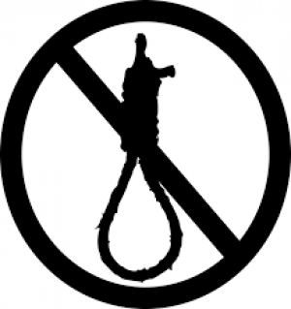
Reasons for the Abolition:
- Social attitudes changed. Many felt that capital punishment stigmatised the families unfairly, and others believed that execution was barbaric and uncivilised. Others disliked the ‘public spectacle’ of executions.
- The Home Secretary prevented over half of all hangings that were supposed to happen, undermining the sentence in the first place. Of the 1,210 death sentences passed between 1900 and 1954, only 632 were carried out.
- The legal system was prone to mistakes, especially in cases of capital punishment. Three high profile cases, where those executed were later pardoned, drew attention to this.
- There was little evidence that abolishing the death penalty would increase the murder rate.

Exam Question: To what extent was the execution of Derek Bentley the main reason for the abolition of the Death Penalty in 1969? 16 marks.

Paragraph | Content
Derek Bentley / Controversial Cases

Social attitudes towards execution / Punishment

Alternative Punishments

Why was Capital Punishment Abolished?
Think of nine reasons for Capital punishment to have been abolished and place them into the diamond in order of importance. Make sure you can explain your reasons.

Punishments in the 20th Century:
Date | Event
1907 | Probation service begins.
1908 | Borstals opened for young offenders.
1919 | Prison warders established and started to receive training.
1922 | Separate system abolished.
1933 | The first open prison was opened/
1948 | Abolition of hard labour in prisons.
1998 | ASBOs created as an alternative.
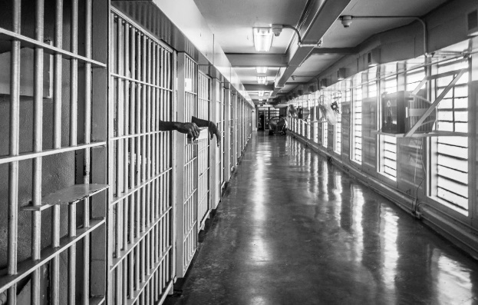
Why did Prison become the normal punishment?
- Abolition of the death penalty.
- Social attitudes turned in favour of reformation and restitution, rather than revenge.
- Governments recognised that prisons could be made harsher in order to calm fears of rising crime levels.
- More humane than the death penalty.

Women, children, and prisons:
- Recent years have seen prison numbers for women rise to roughly 6% of the total prison population.
- Women have always committed less crime. Only between 12 – 20% of all those transported to Australia or America were women, usually to do with crimes like theft or prostitution.
- There are currently 14 women’s prisons, 4 female juvenile units, and 7 ‘mother and baby’ units.
- Women’s prisons follow the same daily routine as men, but they benefit from more health services, and are allowed to spend more time with their children.
- Since 1908, children have been sent to specialist detention centres (first called Borstals).
- Children are forced to spend their time on education and hard work, though they now record higher levels of violent behaviour. Re-offending rates are also very high.
Alternatives to Prison:
- Electronic tagging
- ASBOs
- Community sentences
- Drug and alcohol treatment programmes
These are often criticised for not being strong enough punishments or deterrents for those consider crime.

Why did Prisons become normal punishment?
Attitudes to punishment:  Retribution Restitution:  Human rights:  Aim of prison: | Issues with the death Penalty:  Effective?  Human rights:  Key cases:
Politics:  Political views:  Making prisons harsher:  Winning elections: | Conclusion:

Terrorism:
Why it was a crime? | How was it punished? | Changes?
- Considered to be a form of treason.  - A crime against those in authority.  - Often difficult to detect and tackle, as terrorist groups operate in secret.  - Often aims to cause criminal damage or murder amongst civilian populations in order to achieve a political goal.  - Political goals are often seen as a threat to the government. | - In 1605, the most famous case was Guy Fawkes.  - Fawkes was hanged, drawn, and quartered.  - Noble traitors were beheaded.  - Executions took place in public as a deterrent. | - After 1814, all those found guilty of treason / terrorism were hanged until dead, and then mutilated after death.  - After 1870, drawing and quartering was ended.  - Capital punishment was abolished in 1969.

- Terrorism has been a major challenge for the police since the late nineteenth century. During the 20th Century, groups like the IRA carried out terrorist attacks on Britain. In the 21st Century, the threat of terrorism comes mainly from religious extremists, like Al Quaeda.
- The police work closely with international forces and secret intelligence services to prevent attacks and gain evidence to prosecute those planning them. They use informers and undercover police, and monitor the communications of terrorist suspects.
- Suicide attacks are difficult for the police to deal with as the attackers don’t worry about punishment or who they target. They want to die and kill many others in the process. They are difficult to detect because they work individually or in very small cells.
- Modern technology has made it easier for terrorists to cause maximum damage and not be anywhere near the explosions.
- Modern terrorism is based on suicide attacks. These bombers have no fear of punishment, so are more reckless. They also give no warning, unlike Irish terrorism performed by the IRA.
- Counter-Terrorism measures are expensive and require a lot of organisation. They are unpopular with many citizens. They also increase stop and search procedures.
Exam question:
Explain one difference in the challenges faced by police in the modern period (c.1900 – present) in dealing with the threat of terrorism, in comparison to the Tudor and Stuart period (16th and 17th Centuries). 4 marks.

Conscientious Objection:
Why was it a crime? | How was it punished? | Changes?
- In 1916, the government needed to recruit people into the British Army through conscription.  - Not everybody wanted to join.  - A loophole said people could avoid being conscripted if they were a conscientious objector.  - Many people felt this way, or stronger, after the Second World War. | - 16,000 refused to fight in World War I.  - They were forced to attend tribunals, run by a judge and the military, to judge whether they were genuine or not.  - Only 400 were given exemption.  - 1500 Absolutists were sent to prison.  - Others were given war-work to do.  - 10 died in prison, 63 died after their release, and 31 had nervous breakdowns as treatment in prison was so harsh. | - By World War II, attitudes had changed. Government was more open to objection.  - Many were sympathetic to objectors after their own experiences of the war.  - Women were conscripted in World War II as well.  - 59,000 registered as Conscientious Objectors in 1939. 12,204 were not approved  - The Military were not allowed to run tribunals.

Key dates:
- 1916 – Conscientious Objection becomes a crime for the first time, as this is the first time that the UK has created a conscription law.
- 1939 – Conscription is introduced for the second time in the UK after World War II begins.

First World War | Second World War
- Conscription for men from 1916.  - A clause in law excused conscientious objectors.  - About 16,000 men refused to fight.  - Military tribunals were set up to test claims.  - Only 400 were given complete exemption.  - 1500 absolutists were sent to prison.  - Alternativists were given non-combatant roles, building roads, helping with hospitals, etc.  - Absolutists were imprisoned. 10 died due to harsh treatments, 63 died on release, and 31 had nervous breakdowns. | - Conscription from 1939 for men.  - A clause in the law excused conscientious objectors.  - 59,000 men and women refused to join the army.  - Tribunals judged claims.  - All except 12, 204 were given complete or partial exemption.  - Those with partial exemption were given non-combatant roles.  - A far smaller percentage of those not given exemption were sent to prison, and none were treated as harshly.

Attitudes to objectors:
The attitude of the government changed between World War I and World War II, but for the general public, the attitude was very similar during both wars. Many believed objectors to be cowards. Some were attacked, others lost their jobs.

Domestic Violence:
Why wasn’t it a crime? | Why did it change? | How is it punished?
- Before 1976 it wasn’t. Women were seen as inferior, and the property of their husbands.  - Women had no political power, so were ignored by law makers.  - Law enforcement was dominated by men.  - People did not believe if was the government’s right to interfere in private homes.  - Men were allowed ‘reasonable chastisement’ of their wives.  - Rule of thumb – men could beat their wives with a stick no thicker than their thumb. | - Women received the vote in 1918 and greater equality from then onwards.  - Women could vote for men who would deal with domestic violence.  - Campaign groups for women were set up.  - Media started to concentrate on domestic violence, eg. Eastenders and Brookside.  - Parliament started to raise the issue of domestic violence.  - The government took on a more protective role in society, eg. NHS. | - From 1976, victims could get a non-molestation order to prevent their partner coming home.  - Rape was made illegal in marriage.  - The police were given more powers to investigate.  - Male and female victims were given the same rights in 2004.  - Punished by restraining orders, fines, and prison sentences, but only if they are caught.  - Some still dislike interfering in what they see as the ‘private lives’ of the citizens.

Key Dates in the history of Domestic Violence law:
Date | Change
1976 | Domestic Violence Act – Victims could gain exclusion orders and non-molestation orders, which meant the abuser could not return home.
1990 | The police were told to collect statistics on domestic violence separately to other cases of assault.
1991 | Rape within marriage became a criminal offence.
1996 | Family Law Act gave victims more protection. Arrest became automatic where violence had been used or threatened.
2004 | Domestic Violence, Crime and Victims Act. Male and female victims were given the same protection. The power of the police and courts to act was increased.

Factors that led to changes in the law:
- Campaign groups: Women’s rights groups raised public awareness and put pressure on the government to change the law. Chiswick Women’s Aid was set up by Erin Pizzey in 1971, and the National Women’s Aid Federation was set up in 1974.
- New State Roles: It became more acceptable for the state to interfere in the private lives of the people if it needed to – for example, to protect children, give unemployed people support, and access to the NHS.
- Female Political Power: Since 1928 women have had equal voting rights with men and some have become politicians. It is very important for MPs to try and win women’s votes. In 1971, Jack Ashley was the first MP to raise the issue of domestic violence in Parliament.
- The Media: Newspapers and news programmes reported more incidents of domestic violence and the work of campaign groups, applying more pressure to the government. Domestic abuse storylines also began to feature in popular radio and television dramas, including Eastenders and Brookside.

Timeline of Crime and Punishment:

Early Modern Crimes:  Against Property:  Against Authority:  Against the person: | 1400 | Early Modern Punishments:
 | 1450
 | 1500 | Early Modern attitudes to punishment:
 | 1550
1605: | 1600 | Industrial attitudes to punishment:
 | 1650
 | 1700
Industrial Crimes:  Against Property:  Against Authority:  Against the person: | 1750 | Industrial Punishments:
 | 1800
1868: | 1850 | 1840s:
Modern Crimes:  Against Property:  Against Authority:  Against the person: | 1900 | Modern Punishments:
 | 1950
 | 2000 | 1976:  Attitudes to punishment:
1956 | 2050

Timeline of key events: Read through the timeline and colour code it for the following categories:
- Law enforcement
- Trials
- Punishments
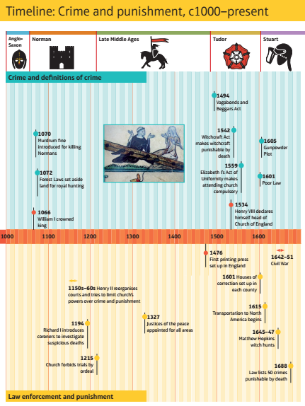
- Crimes

Timeline of key events: Read through the timeline and colour code it for the following categories:
- Law enforcement
- Trials
- Punishments
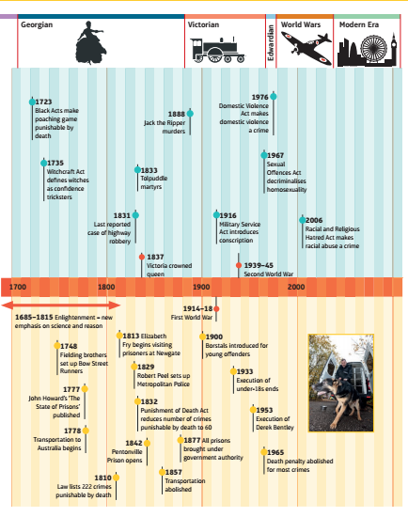
- Crimes
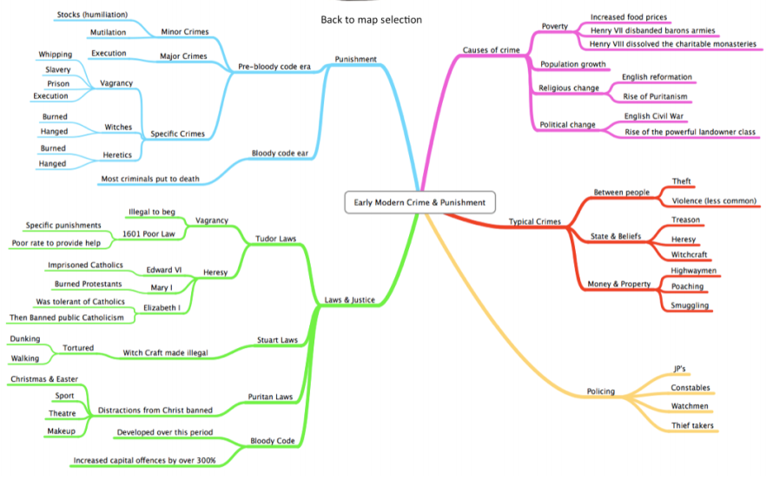
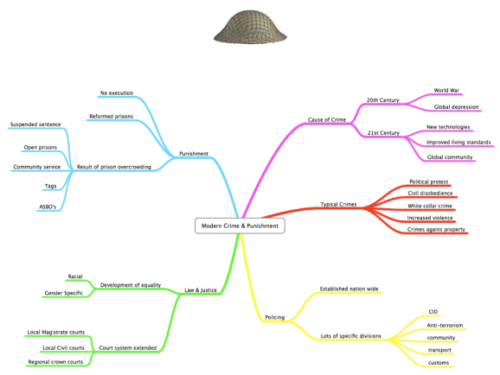
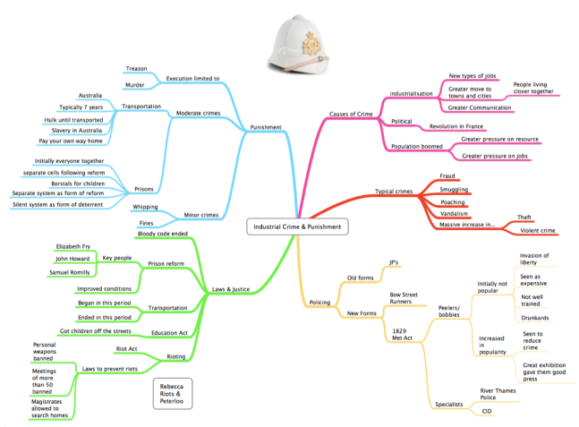

Revision Tip: Use this template when revising the time periods – organise your notes in this manner.

General Mark Scheme for Crime and Punishment:
 | Level 1 | Level 2 | Level 3 | Level 4
Question 3  Key features and analysis of similarity or difference question. | Simple or generalised comments about the issue in the question.  Generalised information about the topic. No link to the question.  1 – 2 marks. | Key features are clearly analysed and explained for similarity or difference.  Specific information is given to support the comparison.  Context used to explain what happened.  3 – 4 marks.
Question 4  Explain why… question.  Analysis of causation / change question. | Simple or generalised answer is given.  Limited knowledge and understanding shown.  1 – 3 | Explanation given with limited analysis.  Some links to causation or change.  Accurate and relevant descriptive material given. No real explanation of the answer.  4 – 6 | Explanation of the answer with analysis and organisation. Answer is supported by accurate knowledge.  Clear attempt to explain an answer and analyse the importance of causes or the rate / pace / nature of change.  7 – 9 | Analytical explanation that is clearly linked to the question and has a clear, reasoned line of argument that is consistent throughout.  Accurate and relevant contextual information is deployed in answer to the question.  Clear understanding of key features and characteristics of the period to support the answer.  10 – 12
Question 5 or 6  Analysis and evaluation of causation / change question  Intro  3x PEEL  +Conclusion | Simple or generalised answer given. Limited knowledge of the period is used.  No judgement given, or simple assertion.  1 – 4 marks. | Descriptive answer with limited explanation and implicit link to the question.  Some organisation, but not sustained.  Accurate descriptive material given in order to support the answer.  5 – 8 marks. | Explanation with some analysis which is directed at the question and the reason for something happening, or the level of change.  Accurate contextual information is given to support the answer.  An overall judgement is reached with some justification, but not clearly expressed or without clear criteria.  9 – 12 marks. | Analytical explanation on the causes of events or the nature and extent of change with a sustained, coherent answer.  Accurate and relevant information is given to support the answer, showing clear understanding of the period (and changes if required).  Clear criteria are applied for reaching a final judgement in answering the question.  13 – 16 marks.

These exam questions are taken from previous crime and punishment papers as well as the specimen papers.
4mark exam questions
Have a go at these crime and punishment exam questions to test your revision.
- Explain one way in which smuggling in Britain during the eighteenth century was similar to smuggling during the twentieth century.
- Explain one way in which the purposes of punishments for crime were different in the 18th and 20th centuries.
- Explain one way in which Norman punishments for crimes against property were different to the punishments for crimes against property in the 19th Century.
- Explain one way in which policing was similar in Tudor England and the early 18th Century.
- Explain one way in which community policing was different in Tudor England and the early 20th Century.
- Explain one way in which treatment of witchcraft in the period 1500-1750 was similar to the treatment of conscientious objection in the 20th Century.
- Explain one way in which conditions in prisons were different in the mid-19th and late 20th centuries.
- Explain one way in which law enforcement in the medieval period (c1000–c1500) was different from law enforcement during the modern period (c1900–present).
- Explain one way in which the treatment of Vagabonds changed from the 15th Century to the 18th Century.
12 mark exam questions
Explain why there were changes in the prison system in the period c1700–c1900.
You may use the following in your answer:
• John Howard
• hard labour
You must also use information of your own.

Explain why there were changes in punishments for witchcraft in the period c1600-c1750.
You may use the following in your answer:
- Mathew Hopkins
- The Royal society
You must also use information of your own.
Explain why there were changes in the number of capital crimes in the period 1800-2000.
You may use the following in your answer:
- The bloody code
- Derek Bentley
You must also use information of your own.

Explain why new crimes were defined in the period from c1900 to the present day.
You may use the following in your answer:
• driving offences
• race crimes
You must also use information of your own.

Why did the government begin using the Bloody Code in the 1600s? You may use the following in your answer:
- Punishment.
- Public attitudes.
You must also use information of your own.

Explain why types of crime changed from c.1000 to c.1700. You may use the following in your answer;
- poaching
- heresy
You must also use information of your own.
Explain why laws against poaching were so difficult to enforce in the 16th, 17th and 18th centuries. You may use the following in your answer:
- Law enforcement.
- Public attitudes.
You must also use information of your own.

Explain why “Trial by ordeal” was used c1000-c1200.
- Trial by hot iron
- Church courts
You must also use information of your own.

Explain why the Normans made changes to crimes and punishments after the Norman Conquest.
- Forest Laws
- Murdrum fine
You must also use information of your own.

Explain why transportation was used as a punishment in the period c1600-c1850.
- -American colonies
- -convict labourers
You must also use information of your own.

Explain why laws against poaching were so difficult to enforce in the 16th, 17th and 18th centuries. You may use the following in your answer:
- Law enforcement.
- Public attitudes.
You must also use information of your own.

Explain why were there changes in criminal activity in the years c1900 to the present day?
- Transport
- The internet
You must also use information of your own.
16 mark exam questions
‘The role of local communities was the most important factor affecting law enforcement during the Middle Ages.’ How far do you agree? Explain your answer.
You may use the following in your answer:
• tithings
• trial by ordeal
You must also use information of your own.
‘The main purpose of punishment during the period c1000–c1700 was to deter people from committing crimes.’ How far do you agree? Explain your answer.
You may use the following in your answer:
• corporal punishment
• the introduction of transportation
You must also use information of your own.
”In the period 1500-1700, the main aim of changes to punishments was retribution.” How far do you agree? Explain your answer. You may use the following in your answer:
- The Bloody code
- Transportation to America.
You must also use information of your own.

“The setting up of the Metropolitan Police Force was the most important development in law enforcement during the period c1700-c1900. How far do you agree? Explain your answer:
You may use the following in your answer:
- The work of the Fielding brothers
- The 1856 Police Act
You must also use information of our own.

“William I’s Forest laws were the most significant changes to crime after the Norman Conquest.” How far do you agree? Explain your answer:
You may use the following in your answer:
- Murdrum fine
- Church court
You must also use information of your own

“Law enforcement was the responsibility of communities between c1300 and c1700.” Explain your answer:
You may use the following in your answer:
- The hue and cry system
- Justice of the Peace Act 1361
You must also use information of your own.

‘Prisons became more effective in the years 1700-1900.’ How far do you agree? You may use the following in your answer:
  - Useful Work.
  - Alternatives.
You must also use information of our own.

‘The role of the local community was the most significant change in trials between c.1100 and c.1900.’ How far do you agree? You may use the following in your answer:
  - The local community.
  - The Judge.
You must also use information of our own.

New’ crimes are simply old crimes in a new format’. How far do you agree? You may use the following in your answer:
  - Car crimes.
  - Computer crimes.
You must also use information of our own.

‘Law enforcement did not change from the c.1300 – c.1829.’ How far do you agree? You may use the following in your answer:
  - Watchmen.
  - The Local Community.
You must also use information of our own.

The role of local communities was the most important factor affecting law enforcement during the Middle Ages.’ How far do you agree? You may use the following in your answer:
  - Tithings.
  - Trial by ordeal.
You must also use information of our own.

